# DMM Measurement Details Lab

Seth Ricks

ECEN 350 - Brother Swenson

9/26/2025

# ECEN 350 Lab – Digital Multimeter Measurement Details Lab (50 points)

(jas, DMM Measurement Details Lab.docx, 9/26/2025)

**Note: You can work in pairs if desired on this lab, although no three person teams are allowed. Submit an electronic version of a lab report to receive credit for doing this lab.** The goal of your **lab report is to provide sufficient documentation so that the lab can be repeated if necessary**. So, for your lab report, **add a cover page, your results, and your answers to the Discussion and Conclusions questions to the existing lab document**. Your cover page is to include class, lab title, along with author or authors. In your **Discussion and Conclusions** section include each of the questions asked in the lab document, along with your responses. While you are to share all **Procedure** items with your lab partner if you worked in a pair, your **Discussion and Conclusions** section is to be uniquely yours and not a copy of your lab partners or anyone else’s answers. A grading rubric for this lab is included at the end of this document. The rubric does not need to be included in your lab report.

**Purpose:** The purpose of this lab is to increase your understanding of the workings and limitations of Digital Multimeters (DMMs), along with becoming familiar with the VirtualBench measurement system from National Instruments. [VirtualBench User Manual](https://content.byui.edu/file/f8b44dda-2a96-41cd-8a40-6a1483b29dc2/1/Labs/virtualbench_user_manual_2025-09-26.pdf).

**Parts and Equipment:**

1 - 10 MΩ Resistor

1 – Portable Digital Multimeter (DMM)

1 - VirtualBench Measurement System and Computer

1 - Breadboard

**Digital Multimeters**

A Digital Multimeter (DMM) is a useful piece of test equipment capable of measuring a multitude of quantities including both AC and DC voltage and current, along with DC resistance. Portable DMMs are quite common as they provide a convenient way of measuring various electrical parameters and are relatively inexpensive (<$50). A Velleman DVM890F Portable DMM is illustrated in **Figure 1**. The portable DMM you use may differ slightly, although look and function similarly to the one illustrated in **Figure 1**. The DVM890F portable DMM provides measurements of AC and DC voltage and current, DC resistance, frequency, capacitance, electrical continuity, and temperature with the addition of a special thermocouple probe. A silicon diode test along with a bipolar transistor current gain (hfe) measurement can also be performed with this versatile piece of test equipment.

**Figure 1**: Velleman DVM890F Portable DMM.

Inexpensive DMMs like the one illustrated in **Figure 1** traditionally utilize a resistive voltage divider across the VΩHz and COM (Common) terminals to achieve the various input voltage ranges as illustrated below in **Figure 2**. The rotary switch setting on the front of the meter determines which node from the resistive voltage divider gets connected to the Internal Analog-to-Digital Converter (ADC). The ADC assigns a numeric value to the associated voltage from the voltage divider, which is then displayed on a numeric display. The ADC senses and measures the selected voltage while requiring negligible current from the voltage divider, resulting in resistors R1 through R5 all having the same current. Consequently, the voltages at the various nodes of the voltage divider can be determined from the voltage divider equations. In **Figure 2**, the nodes of the voltage divider are named N200mV, N2.0V, N20V, N200V and N1000V, corresponding to the 200 mV, 2.0 V, 20 V, 200 V and 1000 V input voltage ranges, respectively. It should be noted that each of the above ranges can measure both positive and negative voltages, such that the 200 mV input range has a full-scale input range of ±200 mV.

The ADC illustrated in **Figure 2** has full-scale range of ±200 mV, corresponding to the smallest DC input voltage range offered. Hence, setting the rotary dial to the N200mV position, i.e., the 200 mV input voltage range, directly routes the voltage appearing across the VΩHz and COM (Common) terminals to the ADC. For the 2.0 V, 20 V, 200 V and 1000 V DC input voltage ranges for the DMM circuitry illustrated in **Figure 2**, the input voltage divider divides down the applied input voltage such that the maximum input voltage for each given range results in 200 mV on the associated voltage divider output node. For example, with the rotary switch set to the N2.0V node of the voltage divider, 2.00 V applied across the VΩHz and COM (Common) terminals results in 200 mV on the N2.0V node, which then gets measured, scaled and displayed as 2.00 V to the user. For the rotary dial switch set to the N1000V voltage divider node, a 1000 V voltage applied to the DMM input results in 200 mV on the N1000V node and ADC input, which is then scaled and displayed as 1000 V. This relatively inexpensive voltage divider approach is the preferred approach for providing multiple input ranges by means of a single ADC.

A large total resistance between the VΩHz input and COM (Common) terminals is desirable so that the DMM requires insignificant current during voltage measurements, with a traditional value being 10 MΩ. For the DMM voltage measurement section illustrated in **Figure 2**, the resulting input resistance for voltage measurements equals 9 MΩ + 900 kΩ + 90 kΩ + 9 kΩ + 9 Ω = 9.999009 MΩ ≈ 10 MΩ. Consequently, the illustrated DMM which is representative of most hand-held DMMs, have an Input Resistance specification, referred to as **Input Impedance**, of 10 MΩ between the VΩHz input and COM (Common) terminals.

**Figure 2:** Typical Portable Digital Multi-Meter (DMM) Voltage Measurement Section.

When measuring voltages that have a high output resistance, the 10 MΩ DMM input impedance (resistance) introduces measurement errors due to current flowing through the DMM voltage divider. More than one engineer has spent valuable time trying to sort out why the measured voltage reported by a portable DMM is lower than expected when connected to a high output resistance circuit, eventually realizing that the 10 MΩ input impedance of the DMM is loading down the circuit. High-end voltmeters offer much higher input resistance than 10 MΩ by utilizing an internal buffer amplifier, resulting in reduced circuit loading for increased equipment cost. The built-in DMM offered by the VirtualBench measurement system allows a selection between either the default 10 MΩ input impedance utilizing a traditional voltage divider, or a high 10 GΩ input impedance for DC voltage measurements on the 100 mV, 1 V, and 10 V input ranges. In some noisy measurement applications, the default 10 MΩ input impedance provides lower noise measurements than the high 10 GΩ input impedance, which is why the built-in VirtualBench DMM offers both options on the 100 mV, 1 V, and 10 V input ranges. [**National Instruments VirtualBench**](http://www.ni.com/virtualbench/what-is/).

National Instruments VirtualBench is illustrated below in **Figure 3** and is a combined instrument that includes a 2-Channel Mixed Signal Oscilloscope (MSO), Function Generator (FGEN), programmable DC Power Supplies (PWS), eight general purpose Digital I/O ports (DIO), along with a Digital Multimeter (DMM). The VirtualBench instrument connects to a computer via USB, with the VirtualBench software providing the necessary user interface to measure and control the various functions. Connect the VirtualBench hardware to a Windows computer using a USB cable. Each VirtualBench is preloaded with the VirtualBench application software accessible from your PC. If Windows AutoPlay is enabled, the VirtualBench application automatically starts. If Windows AutoPlay is not enabled then the application software can be run manually, appearing as a **Device with Removable Storage** on your computer. Run **VirtualBenchLauncher.exe** to start the application. Windows 11 computers can sometimes fail to install the correct drivers when connecting to the Virtual Bench machines. When this happens, the drivers can be installed manually to successfully connect to the Virtual Bench machines. The following document outlines the procedure to manually install the Virtual Bench drivers. [Manual VirtualBench Driver Installation](https://content.byui.edu/file/f8b44dda-2a96-41cd-8a40-6a1483b29dc2/1/Labs/Installing%20Virtual%20Bench%20Drivers%20For%20Windows%2011.docx).

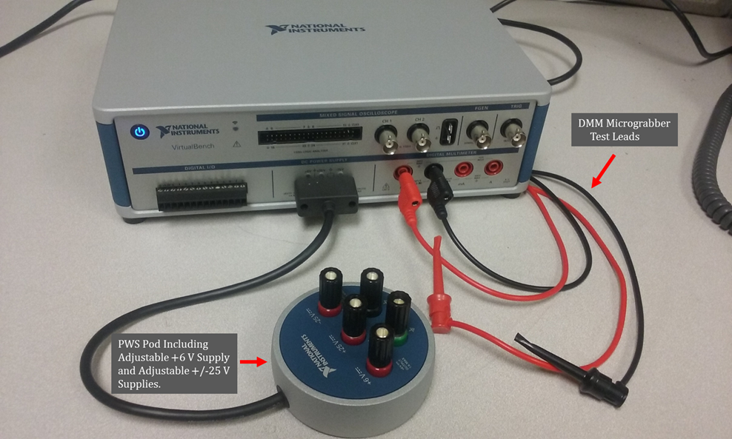

**Figure 3**: National Instrument VirtualBench with PWS Pod and DMM Meter Leads.

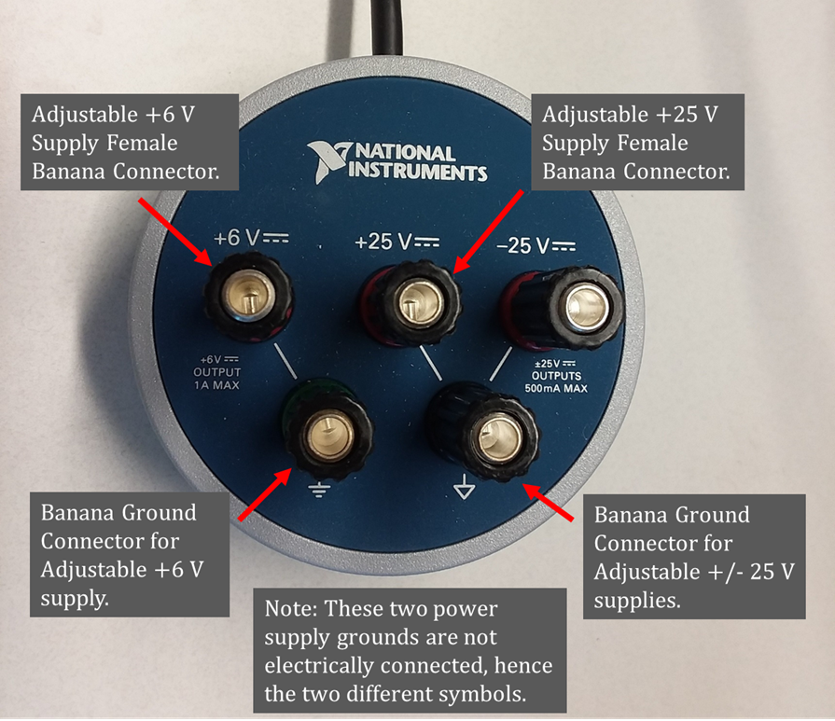

**Figure 4**: Close-Up of VirtualBench PWS Pod.

The VirtualBench User Interface Screen is illustrated below in **Figure 5** with the +6 V adjustable power supply set to 1.000 V, the +25 V adjustable power supply set to 4.000 V. These VirtualBench power supplies are voltage sources with a user programmable current limit, as indicated in **Figure 5**. A current limit on a voltage source is a protective feature that protects both the voltage source and the circuitry connected to the voltage source from excessive current. For a current limited voltage source, the set current limit is never exceeded, even if the output is shorted to ground. As with all current limited voltage sources make sure the current limit setting is greater than the circuit current needed for normal operation, else the actual output voltage will not equal the set output voltage. The default current limit settings of 0.5 A for the +25 V adjustable supply and 1.0 A for +6.000 V adjustable supply, as illustrated in **Figure 5**, are reasonable choices for most applications. The VirtualBench User Interface Screen illustrated in **Figure 5** has the DMM configured to measure DC voltage with a measured voltage of 3.0036 V.

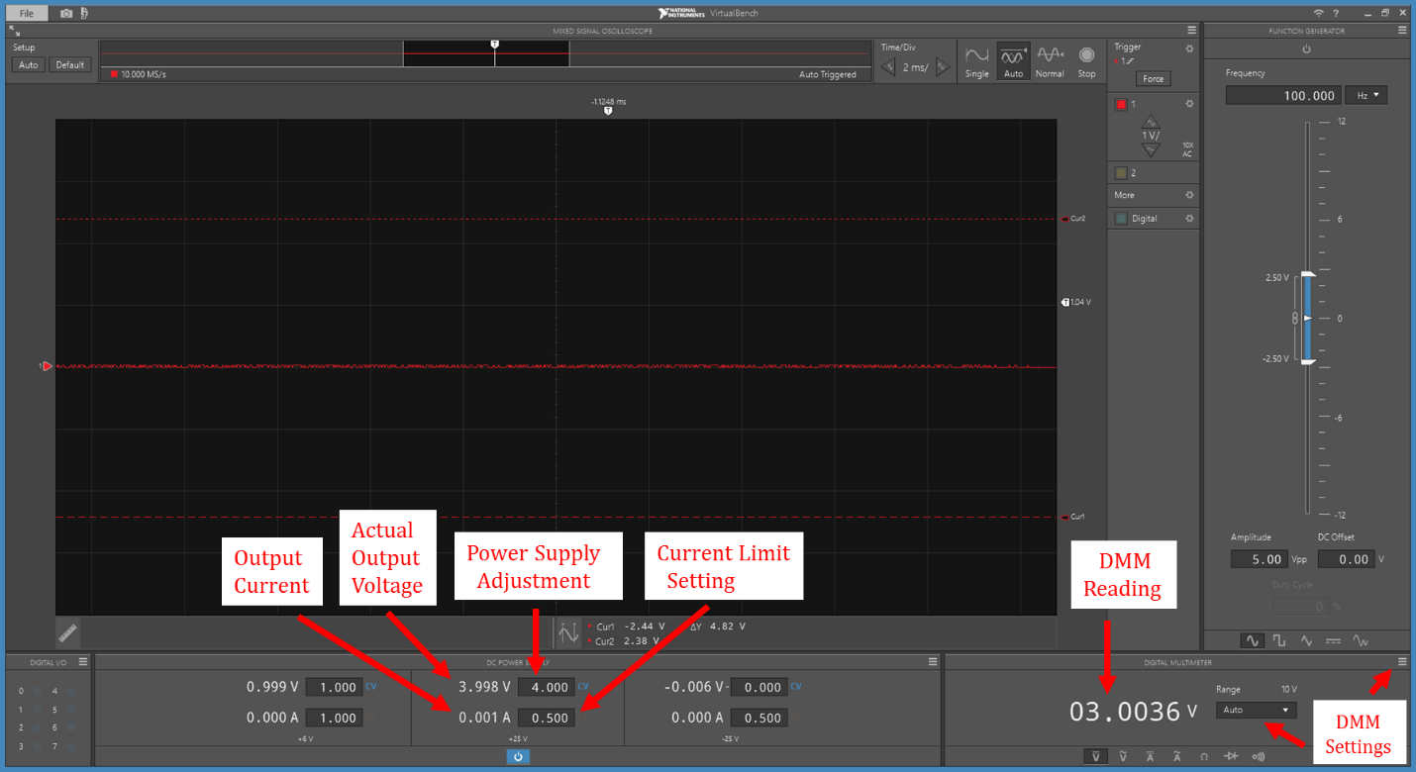

**Figure 5**: VirtualBench User Interface Screen Example.

For this lab you will need the VirtualBench PWS and DMM functions. The adjustable PWS value is set by means of the User Interface Screen as indicated in **Figure 5**. The DMM input connections, i.e., pinout, is illustrated in **Figure 6** below, and can be viewed on-screen at any time by means of selecting the **Pinout** option from the DMM Settings icon  located in lower right-hand corner of the User Interface Screen as illustrated in **Figure 5**.

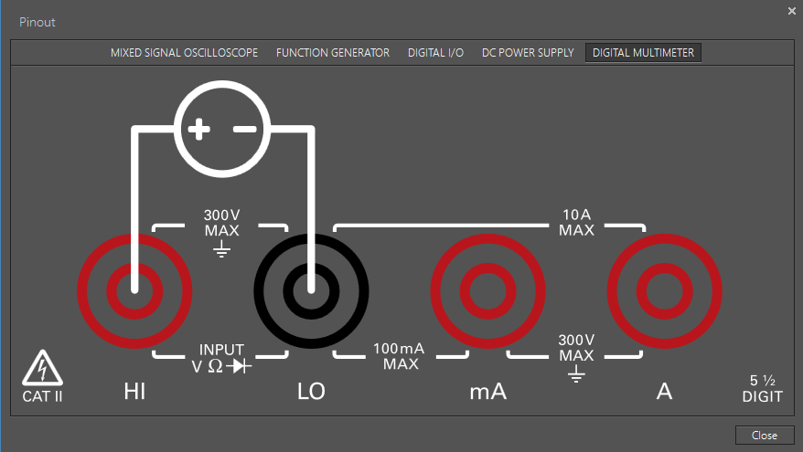

**Figure 6**: VirtualBench DMM Test Lead Connections Illustration, i.e., pinout.

**Procedure:**

**Part 1 – DC Voltage Measurements**

For this lab you are to use both a portable (hand-held) DMM and the DMM available from the VirtualBench measurement system.

1. Configure the portable DMM to measure voltage on the 200mV input range. Configure the VirtualBench DMM to measure resistance (Ω) using Auto range. Connect the VirtualBench DMM to measure the input resistance (impedance) of the portable DMM. This is accomplished by connecting the **LO** input of the VirtualBench DMM to the **COM** of the portable DMM and connecting the **HI** input of the VirtualBench DMM to the **VΩHz** input of the portable DMM. Make sure that the power to the portable DMM is turned on to get an accurate measurement of the input resistance of the portable DMM. After the reading has stabilized, record the VirtualBench DMM resistance measurement below as Rin_Meas of the portable DMM. Change to the 2V, 20V, 200V and 1000V input ranges on the portable DMM, verifying that Rin_Meas remains essentially the same.

Portable DMM Rin_Meas = 10 MΩ

1. 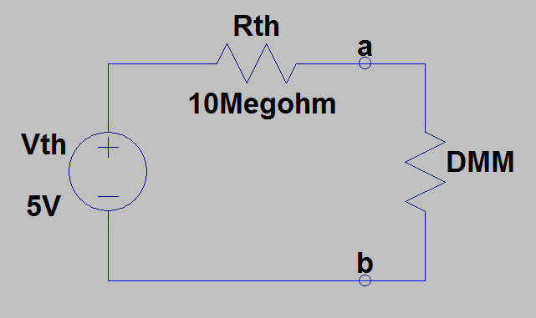Connect up the Thevenin equivalent circuit illustrated in **Figure 7**, by adding a 10 MΩ resistor in series with the output of one of the adjustable VirtualBench power supplies set to 5.000 V as Vth. This circuit represents a 5.000 V Thevenin voltage having a very large (10 MΩ) output resistance/impedance and is to be measured with both the portable DMM and the VirtualBench DMM.

**Figure 7:** Thevenin Equivalent Circuit Constructed with 10 MΩ Rth.

1. Configure the portable DMM to measure DC voltage on the 20 V input range and connect the leads so as to measure the voltage across the a and b terminals as illustrated in **Figure 7**, with the DMM input resistance/impedance representing the resistive load. Record the resulting measured voltage in the first column of **Table 1** below using three significant figures. Be sure to include units for measured values, either by adding them to the column label or to each value.
2. After recording the measured voltage value, disconnect the portable DMM from the circuit of **Figure 7**, and turn it off to conserve battery lifetime.
3. Configure the VirtualBench DMM to measure DC voltage on the 10 V input range and connect the leads to measure the voltage a and b terminals as illustrated in **Figure 7**. Record the resulting measured voltage in the second column of **Table 1** below, rounding to three significant figures.
4. The VirtualBench DMM default input impedance for voltage measurements is 10 MΩ, the same as the portable DMM. The VirtualBench DMM offers a High (10 GΩ) Input Impedance setting for voltage measurements on the 100 mV, 1 V, and 10 V input ranges, when Auto Ranging is not selected. Using the DMM Settings Icon , select the **High Impedance (10 GΩ)** option for the 10 V input range of the VirtualBench DMM, then record the resulting measured voltage across the a and b terminals in the third column of **Table 1** below, rounding to three significant figures.
5. Turn off the Virtual Bench power supplies. The breadboard and VirtualBench power supplies will not be needed for the remainder of this lab. (9 points total.)

**Table 1**: Measured Results from the Thevenin Equivalent Circuit Illustrated in **Figure 7**.

|  |  |  |
| --- | --- | --- |
| Portable DMM Measurement  (10 MΩ Input Impedance) | VirtualBench DMM with Normal (10 MΩ) Input Impedance | VirtualBench DMM with High (10 GΩ) Input Impedance |
| 1.58 V | 1.58 V | 3.30 V |

**Part 2 – DC Current Measurements**

**Warning: DMMs configured for DC Current Measurements include internal fuse protection against excessive currents caused by accidentally connecting the test leads across a voltage source such as bench power supply or battery. The portable Velleman DMMs incorporate an internal 0.25 A fuse that is easily blown by an accidental connection across a voltage source, whereas the VirtualBench DMMs incorporate a 1.25 A fuse, which is less likely to blow when using current limited supplies. Consequently, it is usually best to avoid current measurements with a portable DMM when other options are available, such as measuring the voltage across a known resistance. If you find a DMM with a blown fuse, please take the DMM to a lab assistant for fuse replacement.**

The circuitry to measure DC current by means of a traditional portable DMM is illustrated in **Figure 8**. Conventional current flowing into the mA terminal and exiting the COM terminal flows through one of the 1 Ω, 10 Ω or 100 Ω sense resistors, as determined by the rotary dial position. The resulting voltage across the selected sense resistor is then measured by the Analog-to-Digital Converter (ADC). Measured current is then determined by means of Ohm’s law, i.e., Imeas = V/Rsense, with internal circuitry performing the calculations and displaying the measured result. Hence, to measure current via a DMM, the selected internal current sense resistor must be connected in series with the external current to be measured. Consequently, inserting a DMM configured as an ammeter into a circuit introduces additional series resistance, decreasing the circuit current. As a result, the in-circuit current with the DMM ammeter present is always less than the in-circuit current without the ammeter present, resulting in a current measurement error.

**Figure 8**: Current Measurement Circuit for the Velleman Portable DMM.

As illustrated in **Figure 8**, ammeters provide a low resistance between the current in (mA) and the COM terminal, making this circuitry vulnerable to damage when connected incorrectly. For example, it is not uncommon to forget to unplug the lead plugged into the mA terminal after a current measurement prior to connecting the leads to a DC voltage for a voltage measurement. This oversight often leads to undesirably large currents flowing through low-resistance sense resistors. It is for this reason that DC current measurement circuitry often includes a one-time blowable fuse to protect the sense resistors from damage from excessive current due to an inadvertent connection. If you struggle with what appears to be an open circuit when performing a DC current measurement with a DMM, it is likely that the ammeter circuit has a blown fuse, requiring fuse replacement for proper operation.

This portion of the lab is to characterize the internal resistance values of the portable DMM for the 2 mA, 20 mA and 200 mA DC Input Current Ranges, by measuring the internal resistance of the portable DMM with the VirtualBench DMM.

1. Configure your portable DMM to measure current on the 2 mA DC input range.
2. Configure the VirtualBench DMM to measure resistance (Ω) using the 100 Ω range. The VirtualBench DMM has a **Null Offset** function selected by means of the DMM Settings Icon . This **Null Offset** function is to be used to remove the resistance associated with the meters internal contact resistance, fuse resistance and resistance of the test leads for a given measurement range. The Null Offset function cannot be used with Auto ranging, as each measurement range will have a different Null Offset value.
3. Connect both the red and black test leads of the VirtualBench DMM together to measure the resistance of the test leads, etc., of the DMM. Then invoke the **Null Offset** function to subtract and therefore eliminate the unwanted resistance of the VirtualBench test leads, etc., from the subsequent resistance measurements to be taken.
4. Next connect the red and black leads of the VirtualBench DMM to the red and black leads of the portable DMM to measure with the VirtualBench DMM the input resistance of the portable DMM when the portable DMM is configured to measure current. (Note: Some portable DMMs may have an Input Resistance that is larger than can be measured on the VirtualBench 100 Ω range. If that occurs then change the VirtualBench resistance (Ω) range to the 1 kΩ range, which will require you to repeat the Null Offset procedure for the new measurement range. Be sure to go back to the VirtualBench 100 Ω measurement range for the 20mA and 200mA DC Current Input Ranges measurements associated with **Table 2** below, and then repeating the **Null Offset** procedure on the 100 Ω range.)
5. Record your Measured Input Resistance Associated with the Current Measurement for the portable DMM for the 2 mA, 20 mA and 200 mA input ranges in **Table 2** below using three significant figures. Be sure to include units for measured values, either by adding them to the column label or to each value. The associated resistance associated with 10 A current measurement range on the portable DMM is too small to be accurately measured by the VirtualBench DMM and so is not included in **Table 2**. (9 points total.)

**Table 2**: Measured Resistance Associated with Current Measurements for the 2 mA, 20 mA and 200 mA DC Input Current Ranges for the Portable DMM Characterized in this Lab.

|  |  |
| --- | --- |
| **DC Current Input Range** | **Measured Input Resistance Associated with the Current Measurement** |
| 2mA | 102.6 Ω |
| 20mA | 12.9 Ω |
| 200mA | 3.6 Ω |

As previously mentioned, inserting a DMM configured as an ammeter into a circuit, as illustrated in **Figure 9** below, introduces additional series resistance that decreases the actual circuit current, resulting in a measurement error.

**Figure 9**: Current Measurement Circuit for a 1.5 V Battery and 200 Ω Resistor.

1. Using your measured **Table 2** resistance values for the 20 mA range of the portable DMM along with the Maximum Resistance specification of 3 Ω for the 10 mA input range of the VirtualBench DMM, calculate and record below the current measurement error for the circuit illustrated in **Figure 9**. Express your measurement error as a percentage of the ideal circuit current denoted as Iwithout_DMM. The Percent Error in measured current is to be calculated as follows:

IDiff % = 100[(Iwith_DMM – Iwithout_DMM)/ Iwithout_DMM].

Include your percent error calculations for the portable DMM and VirtualBench DMM below. Be sure to include the sign of the error in your answer. (6 points, 3 points each.)

Portable DMM Measured Current Percent Error = -6.06%

VirtualBench DMM Measured Current Percent Error = -1.47%

**Part 3 – Resolution and Accuracy**

The DMM illustrated in **Figure 1** is said to have a 3 ½ digit display, with the 3 right-most digits consisting of the traditional full 7-segments used to display the numerals 0 through 9, along with the left-most ½ digit consisting of only 2 vertical segments. Fractional digits are defined as follows:

The left-most digit in **Figure 10**, referred to as a ½ digit, can either appear blank, i.e., invisible, representing an implied 0 on the left, or can have both vertical segments fully visible, representing the numeral 1. Hence, the Maximum Digit Value for the left-most digit in **Figure 10** equals 1, while the Number of Possible States equals 2, resulting in a fractional digit value of ½ from the above formula.

**Figure 10**: 3 ½ Digit Display Example.

In summary, the left-most digit in **Figure 10** is a fractional ½ digit because it is either not visible, which is an implied 0, or visible as a 1. Hence, the maximum value of a 3 ½ Digit Display is 1999, while the minimum value is -1999. Also included in LCD displays is a decimal point that can be visibly located between any of the digits or be invisible.

DMM measurement resolution is the smallest numeric change that can be displayed, which occurs when the right-most digit changes by one unit. For example, on the 3 ½ digit display of **Figure 10** for a 2 V full-scale measurement range, the resolution of a measured voltage of 1.999 V equals 0.001 V, i.e., 1 mV. Whereas a voltage of 2.2 V would need to be measured on the next larger input range, i.e., the 20 V range, and displayed as 2.00 V on a 3 ½ digit display, having a resolution of 0.01 V, i.e., 10 mV.

All measurements contain some amount of error because of imperfections in the measurement process and equipment. For example, a ruler for measuring length has non-zero errors along the scale, resulting in errors in measured lengths. For DMMs, imperfections in the actual voltage divider resistors and current sense resistors result in non-zero voltage and current measurement errors. Many manufacturers of sensors and measurement equipment have traditionally used the term accuracy when referring to limits of measurement error. While inaccuracy seems more appropriate, the term accuracy is commonly used with the understanding that smaller is better, i.e., a more accurate measurement implies smaller measurement error. The accuracy of measurement instruments such as DMMs is often characterized by a slope error and an offset error. For DMM voltage measurements, slight errors in the resistor values results in ratio or slope errors. Also, the internal voltage reference used for the Analog-to-Digital Converter (ADC) of DMMs is nonideal, which also contributes to a slope error. Unavoidable offset voltages result in offset errors, meaning that a zero input results in a non-zero measured result.

For the Velleman 3 ½ digit DMM in **Figure 1**, the specified DC voltage measurement accuracy for the 200mV, 2V, 20V, and 200V input ranges is specified as follows:

Accuracy = ±0.5% of Reading ±1 Digit.

In the above equation, the slope error is arrived at by the 0.5% of reading error multiplied by the displayed reading, whereas Digit refers to the least significant value or resolution of the displayed reading.

So, the accuracy of a 1.000 V reading is determined as follows:

(1.000 V)(0.5%)/100 = 5 mV, whereas 1 Digit = 0.001, i.e., 1 mV, for a 1.000 V reading.

Therefore, the total accuracy or estimated limits of measurement error from the DMM equals ±(5 mV + 1 mV) = ±6 mV. This implies that a reading of 1.000 V, means that the actual voltage measured was somewhere within the range of 0.994 V to 1.006 V for the Velleman DVM890F Portable DMM.

For the 3 ½ digit DMM in **Figure 1**, the specified DC current measurement accuracy for the 2mA, and 20mA input ranges is as follows:

Accuracy = ±0.8% of Reading ±1 Digit.

For example, a 10 mA reading on the 20mA range would be displayed as 10.00 mA, so that a digit equals 0.01 mA or 10 µA.

1. Determine the DC voltage measurement accuracy of a Velleman DVM890F Portable DMM for a measured result of 12 V on the 20V range. Express your final results as the range defined by Vmin and Vmax for the measured result, including units in your answer.

12 * 0.5/100 ± 0.01

Vmin = 11.93V (2 points.)

Vmax = 12.07V (2 points.)

**Discussion and Conclusions Questions:** (For the following questions use your own words along with complete sentences or equations. Points are to be deducted for AI generated answers.)

1. Using the Thevenin Equivalent circuit shown in **Figure 7**, calculate the value of DMM input resistance necessary to have the voltage across the a and b terminals within 1% of Vth. (5 points.)

990 MΩ

1. Referring to the Thevenin Equivalent circuit of **Figure 7**, explain why increasing the VirtualBench voltmeter input impedance from the default of 10 MΩ to 10 GΩ resulted in a measured voltage across the a and b terminals much closer to the 5.000 V Thevenin Equivalent voltage. (4 points.)

Because of the bigger input impedance, the voltage divider results in a much larger voltage across the DMM. This means that it is closer to the value of the original Thevenin voltage. Theoretically, if the input impedance was infinity, then the voltage across the DMM would be the same as the Thevenin Equivalent voltage.

1. Describe what measurement accuracy means. (2 points.)

Accuracy is the percentage that represents the limits of measurement error. If the measurement is 100V and the accuracy is 1%, then the measurements would be in a range of 99V to 101V.

1. The specified Accuracy equals ±0.5% of Reading ±1 Digit for DC voltage measurements for the Velleman DVM890F Portable DMM. Explain why the most accurate measurements result from choosing the smallest possible input voltage range that will not over-range for a given voltage measurement. (2 points.)

If the voltage to be measured is over the range, the reading will not be accurate. It will either read the largest value that the range can give, or say something like “0L”. For example, if we are trying to measure 5V with the 200mV setting, it will either say 200mV, or “0L”. But if we do the same measurement on 20V, it would say around 5V.

1. **Extra Credit Question**: Explain why a one-time blowable fuse is included between the mA and COM terminals of the DMM current measurement circuitry illustrated in **Figure 8**, whereas no fuse is included between the VΩHz and COM terminals of the DMM voltage measurement circuitry illustrated in **Figure 2**. (4 Points.)

Current is measured in series, while voltage is measured in parallel. When we are measuring voltage, there is a very high internal resistance, as we calculated before. This means that almost no current will flow through the DMM. That means that there isn’t really a risk of blowing a fuse. On the contrary, when the DMM is in parallel, there is the possibility of the current being higher than the meter can take. That is why the fuse is there, so that the internal wiring and components are protected from high currents.

**DMM Measurement Details Grading Rubric:** For this lab, **add a cover page, your results, and your answers to the Discussion and Conclusions questions to the existing lab document**. Your cover page is to include class, lab title, along with author or authors. In your **Discussion and Conclusions** section include each of the questions asked in the lab document, along with your responses. While you are to share all **Procedure** items with your lab partner if you worked in a pair, your **Discussion and Conclusions** section is to be uniquely yours and not a copy of your lab partners or anyone else’s answers. The following rubric does not need to be included in your lab report.

|  |  |
| --- | --- |
| **Lab Report Item** | **Points** |
| Cover Page | 2 |
| **Part 1 – DC Voltage Measurements**  Reasonable portable DMM Rin_Meas value with units. (3 points, -0.25 points for missing unit) | 3 |
| Reasonable **Table 1** values with units. (3 points per entry, -0.25 points for each missing unit.) | 9 |
| **Part 2 – DC Current Measurements**  Reasonable **Table 2** values with units. (3 points per entry, -0.25 points for each missing unit.) | 9 |
| Measured Current Percent Error Calculations. (3 points for Portable DMM, 3 points for VirtualBench DMM, 0.5 points for correct sign.) | 6 |
| **Part 3 – Resolution and Accuracy**  (2 points each for Vmin and Vmax.) | 4 |
| Discussion and Conclusions (Not including 4 point Extra Credit.) | 13 |
| Grammar and Professionalism | 4 |
|  |  |
| **Total** | 50 |

Please give feedback on typos, etc. you find for this lab handout.